Supplemental material
Table S1. Delphi consensus on responses generated by three large language models to non-muscle-invasive bladder cancer management questions. 3
Table S2. Number of panelists, median score, and interquartile range for each question and large language model in non-muscle-invasive bladder cancer. 7
Figure S1. Proportion of panelists scoring in each category (1–3 = disagreement, 4–6 = no consensus, 7–9 = agreement) per response and large language model in non-muscle-invasive bladder cancer after both Delphi rounds. 8
Table S3. Delphi consensus on responses generated by three large language models to muscle-invasive bladder cancer management questions. 9
Table S4. Number of panelists, median score, and interquartile range for each question and large language model in muscle-invasive bladder cancer. 13
Figure S2. Proportion of panelists scoring in each category (1–3 = disagreement, 4–6 = no consensus, 7–9 = agreement) per response and large language model in muscle-invasive bladder cancer after both Delphi rounds. 14
Table S5. Delphi consensus on responses generated by three large language models to upper tract urothelial carcinoma management questions. 15
Table S6. Number of panelists, median score, and interquartile range for each question and large language model in upper tract urothelial carcinoma. 20
Figure S3. Proportion of panelists scoring in each category (1–3 = disagreement, 4–6 = no consensus, 7–9 = agreement) per response and large language model in upper tract urothelial carcinoma after both Delphi rounds. 21

Table S1. Delphi consensus on responses generated by three large language models to non-muscle-invasive bladder cancer management questions.
Guideline-based questions | Delphi results by LLM^{1,2} |  |  | Summary of main panelists’ comments
Guideline-based questions | Claude | Gemini | ChatGPT | Summary of main panelists’ comments
- A 69-year-and-11-month-old male patient in good general condition with an optimal health status presents with a history of hypertension, diabetes mellitus, and former tobacco use (quit 5 years ago after smoking one pack daily). One month prior, he was diagnosed by ultrasound with a primary bladder tumor, revealing a 1.5 cm lesion on the right lateral wall. An en bloc transurethral resection was performed without complications; intraoperative cystoscopy showed no additional lesions or bladder perforation. Macroscopically, the pathology specimen included muscle tissue. At the end of the procedure, urine was clear, so no postoperative intravesical chemotherapy instillation was administered, considering the resection complete and radical. On follow-up three weeks later, the pathology report confirmed a high-grade pure urothelial carcinoma (pTa), with no associated carcinoma in situ (CIS). Random biopsies were not performed, but the absence of CIS was assumed, classifying the patient as intermediate risk. The patient was informed about his adverse prognosis—an estimated 62% probability of progression and over 40% mortality at five years—and immediate radical cystectomy was proposed.  Was the chosen diagnostic and therapeutic approach the most appropriate in this case? | 2nd round (87.5%) | 1st round (75.0%) | 1st round (75.0%) | Claude: There are some inconsistencies and a need for further fine-tuning.  Gemini and ChatGPT: The responses contain some inaccuracies.
- In patients with low-grade (TaG2) bladder tumors without CIS, treated with complete transurethral resection followed by immediate mitomycin instillation, is any additional treatment required, or is this strategy sufficient to consider the patient in remission? | 2nd round (75.0%) | 1st round (75.0%) | 2nd round (75.0%) | Claude: The response contains misinterpretations and lacks focus on the main question.  Gemini and ChatGPT: The responses are incomplete.
- In the follow-up of very high-risk bladder tumor patients treated with BCG induction and three years’ maintenance, can the Epicheck biomarker be used exclusively in place of regular cystoscopies? Is any other surveillance necessary, given the high negative predictive value of this marker for urothelial carcinoma diagnosis? | 1st round (100%) | 2nd round (100%) | 1st round (87.5%) | Claude: provides the best response.
- What is the rationale for a single, immediate intravesical chemotherapy instillation following transurethral resection (TURB) in patients with Ta or T1 bladder tumors? | 1st round (87.5%) | 1st round (100%) | 2nd round (100%) | ChatGPT: The response is incomplete.
- What is the management of cystitis symptoms derived from intravesical BCG administration? | 1st round (85.7%) | 1st round (85.7%) | 1st round (71.4%) | Claude: The response lacks alignment with clinical priorities.  Claude and Gemini: Perfect translation into Spanish of the corresponding table from the European guidelines.
- What were the outcomes of the DaBlaCa-13 trial comparing mitomycin C chemoablation versus TURB in NMIBC, and in which situations might this strategy be considered? | 1st round (100%) | 1st round (87.5%) | 2nd round (87.5%) | ChatGPT: The responses contain some inaccuracies.
- How should papillary high-grade non–muscle-invasive bladder cancer (Ta-T1) refractory to BCG be managed? | 1st round (75.0%) | 1st round (75.0%) | 1st round (75.0%)
- What is the optimal duration of BCG maintenance therapy for high-risk NMIBC? | 1st round (100%) | 1st round (87.5%) | 2nd round (87.5%)
- How should a low-risk NMIBC patient who did not receive perioperative MMC instillation be managed? | 1st round (87.5%) | 1st round (87.5%) | 1st round (75.0%) | Claude and ChatGPT: The response is correct but lacks focus on the main question.
- What intravesical treatment should be administered to a patient with an intermediate-risk bladder tumor? | 1st round (100%) | 1st round (100%) | 1st round (100%) | Claude, Gemini and ChatGPT: The responses should be more detailed.
- Should a diagnostic TURB be performed in a patient whose MRI clearly shows a muscle-invasive bladder tumor? | 1st round disagreement (75.0%) | 1st round (100%) | 1st round (100%) | Claude: The response is incorrect and raises doubts about the model’s reliability.
- In a patient with high-risk NMIBC who has completed BCG induction and two years of maintenance but experiences BCG failure at year 4, what is the most appropriate treatment? | No consensus (37.5%) | 1st round (100%) | 1st round (100%) | Claude: The response lacks nuance and sufficient clinical detail; the software translates well but fails to interpret information accurately.
- Should a second transurethral resection (re-TUR) be systematically performed in all patients with high-grade T1 tumors, even if the initial resection appears complete and muscle is present in the specimen? In other words, are there any high-grade T1 tumors where re-TUR could be omitted? | 1st round (87.5%) | 1st round (100%) | 1st round (100%) | Claude: The response is incomplete.
- What is the BEST therapeutic option for patients with persistent isolated CIS without anatomical progression after multiple BCG cycles? | 1st round (87.5%) | 1st round (75.0%) | 1st round (75.0%) | Gemini: The response is incomplete.
- Can artificial intelligence (AI) be effectively applied to improve prediction of recurrence or progression in NMIBC? | 2nd round (87.5%) | 1st round (100%) | 1st round (100%) | Claude: The response lacks focus on the main question.
- How should the following pathology report be managed: high-grade papillary urothelial carcinoma with thermal artifact preventing assessment of invasion depth? | 1st round (100%) | 1st round (100%) | 1st round (100%)
- How should the following pathology report be managed: low-grade papillary urothelial carcinoma with focal lamina propria invasion? | No consensus (25.0%) | 2nd round (75.0%) | No consensus (62.5%) | Claude, Gemini and ChatGPT: The responses contain inaccuracies.
- How should the following pathology report be managed: high-grade solid urothelial carcinoma with lymphoepithelioma-like histological variant? | 1st round (75.0%) | 1st round (87.5%) | 1st round (75.0%) | Claude: The response is overly elaborate and lacks specific, substantive conclusions.  Claude and Gemini: The responses contain inaccuracies.
- I have a patient with a high-grade Ta bladder tumor treated with BCG for one year who refuses surveillance cystoscopies; which biomarker would you recommend? | 1st round (100%) | 1st round (100%) | 2nd round (87.5%) | Claude: The response is incomplete.
- In which patients is surveillance de-intensification appropriate for non–muscle-invasive bladder tumors? | 1st round (87.5%) | 1st round (87.5%) | 1st round (75.0%) | Claude, Gemini and ChatGPT: The responses are incomplete.
- In which patients should a CT scan be performed? | 1st round (87.5%) | 1st round (87.5%) | 1st round (87.5%) | Claude and Gemini: The responses contain inaccuracies.
- Should any patient with positive cytology—regardless of the presence of papillary tumor—undergo random bladder biopsies? | 2nd round (100%) | 1st round (87.5%) | 2nd round (87.5%) | Claude: The response translates the European guideline but does not address the specific question asked.  Gemini: The response is incomplete.
- What management should be taken for a high-risk tumor patient with BCG intolerance? | 1st round (85.7%) | 1st round (100%) | 1st round (85.7%)
- When offering adjuvant intravesical mitomycin therapy for intermediate-risk tumors, does the treatment schedule differ depending on whether a single immediate postoperative chemotherapy dose was administered? | 1st round (100%) | 1st round (100%) | 1st round (100%)
- Is there a patient profile that may benefit from bladder cancer screening? | 1st round (87.5%) | 1st round (87.5%) | 1st round (100%) | Claude: the software translates well but fails to interpret information accurately.
Abbreviations: BCG, Bacillus Calmette-Guérin; CIS, Carcinoma in situ; CT, Computed Tomography; MRI, Magnetic Resonance Imaging; NMIBC, Non-Muscle-Invasive Bladder Cancer; TURB, Transurethral Resection of Bladder Tumor.

¹ ‘1st round’ or ‘2nd round’ indicates consensus was reached in the first or second Delphi round, respectively.
² The percentage in parentheses indicates the proportion of panelists whose scores fell within the same tercile as the median of responses (1–3 = disagreement, 4–6 = no consensus, 7–9 = agreement).

Color code for consensus levels:
- Dark green: Consensus in agreement reached in the first round.
- Light green: Consensus in agreement reached in the second round.
- Dark orange: Consensus in disagreement reached in the first round.
- Yellow: No consensus reached.

Table S2. Number of panelists, median score, and interquartile range for each question and large language model in non-muscle-invasive bladder cancer.
Question¹ | Claude |  | Gemini |  | ChatGPT
Question¹ | n | Median (IQR) | n | Median (IQR) | n | Median (IQR)
1 | 8 | 7 (1) | 8 | 7 (2) | 8 | 7.5 (2)
2 | 8 | 7 (2) | 8 | 7.5 (3) | 8 | 7 (3)
3 | 8 | 8.5 (1) | 9 | 7 (1) | 8 | 8 (1)
4 | 8 | 9 (2) | 8 | 8 (1) | 8 | 8 (0)
5 | 7 | 9 (1) | 7 | 8 (2) | 7 | 7 (3)
6 | 8 | 8.5 (2) | 8 | 7.5 (1) | 8 | 7.5 (1)
7 | 8 | 8.5 (3) | 8 | 7 (2) | 8 | 7.5 (3)
8 | 8 | 8.5 (1) | 8 | 8 (1) | 8 | 9 (2)
9 | 8 | 8 (2) | 8 | 8.5 (2) | 8 | 7.5 (3)
10 | 8 | 8 (2) | 8 | 8 (2) | 8 | 8 (1)
11 | 8 | 1.5 (3) | 8 | 8.5 (1) | 8 | 8.5 (1)
12 | 8 | 6 (8) | 8 | 8 (1) | 8 | 8 (2)
13 | 8 | 9 (1) | 8 | 9 (1) | 8 | 9 (1)
14 | 8 | 8 (2) | 8 | 7 (2) | 8 | 8 (3)
15 | 8 | 8 (1) | 8 | 8 (2) | 8 | 9 (1)
16 | 8 | 9 (1) | 8 | 8.5 (1) | 8 | 9 (1)
17 | 8 | 6 (5) | 8 | 8 (5) | 8 | 7 (5)
18 | 8 | 7 (4) | 8 | 8 (2) | 8 | 8 (3)
19 | 8 | 7 (1) | 8 | 8 (2) | 8 | 8 (1)
20 | 8 | 8 (2) | 8 | 8 (1) | 8 | 8 (3)
21 | 8 | 7.5 (2) | 8 | 8.5 (1) | 8 | 7.5 (2)
22 | 8 | 8 (1) | 8 | 8 (2) | 8 | 7 (1)
23 | 7 | 7 (1) | 7 | 9 (1) | 7 | 9 (1)
24 | 7 | 8 (1) | 7 | 8 (1) | 7 | 9 (1)
25 | 8 | 8 (1) | 8 | 8 (1) | 8 | 8 (2)
Abbreviations: IQR, interquartile range.
¹ Question numbers correspond to those reported in Table S1. For each model and question, n indicates the number of panelists who submitted a rating. Abstentions were excluded.

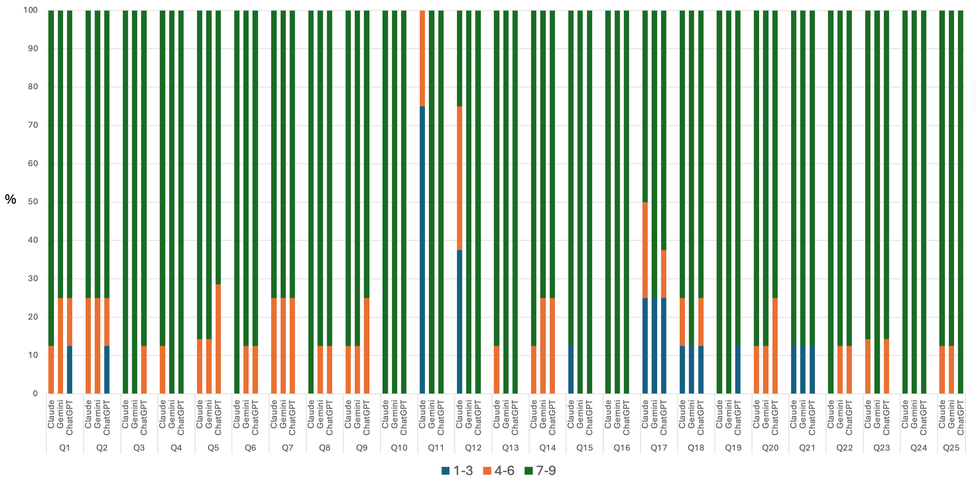
Figure S1. Proportion of panelists scoring in each category (1–3 = disagreement, 4–6 = no consensus, 7–9 = agreement) per response and large language model in non-muscle-invasive bladder cancer after both Delphi rounds.

Table S3. Delphi consensus on responses generated by three large language models to muscle-invasive bladder cancer management questions.
Guideline-based questions | Delphi results by LLM^{1,2} |  |  | Summary of main panelists’ comments
Guideline-based questions | Claude | Gemini | ChatGPT | Summary of main panelists’ comments
- When should magnetic resonance imaging (MRI) be performed in bladder cancer? | No consensus (44.4%) | 1st round (80%) | No consensus (66.6%) | Claude: Response too brief and not entirely correct.  Gemini and ChatGPT: Not entirely in agreement with some response options based on current evidence.
- What is the diagnostic accuracy of CT and MRI for detecting lymph node involvement? What size threshold should we consider in the pelvic and abdominal regions? | 1st round (88.9%) | 1st round (88.9%) | 1st round (88.9%)
- If I find a separate tumor cluster in the perivesical fat without evidence of lymph node structure, is this considered N+? | 1st round (88.9%) | 1st round (88.9%) | 1st round (88.9%)
- Is it necessary to report the presence of carcinoma in situ (CIS) in areas other than the invasive carcinoma? | 1st round (100%) | 1st round (90.0%) | 1st round (90.0%)
- In a T1 micropapillary variant, what is the recommended treatment? | 1st round (100%) | 1st round (90.0%) | 1st round (90.0%)
- Does the presence of a non–muscle-invasive bladder tumor in the bladder neck or prostatic urethra contraindicate the creation of an orthotopic neobladder? | 1st round (85.7%) | 1st round (85.7%) | 1st round (100%)
- In which patients can prostate-sparing techniques be offered during cystectomy in men, and what are the success rates in terms of sexual potency and urinary continence? | 1st round (77.8%) | 1st round (100%) | 1st round (88.9%)
- How should follow-up be conducted for patients undergoing radical cystectomy for muscle-invasive bladder tumor? | 2nd round (88.9%) | 1st round (100%) | 1st round (88.9%)
- What percentage of patients may develop a ureteroenteric stricture after radical cystectomy? | 1st round (77.8%) | 1st round (77.8%) | 1st round (77.8%)
- What is the mortality rate associated with palliative cystectomy? | 1st round (88.9%) | 1st round (88.9%) | 1st round (88.9%)
- Does salvage cystectomy after chemoradiation for bladder preservation carry more complications than standard cystectomy? | 1st round (88.9%) | 2nd round (100%) | 1st round (88.9%)
- Is the ideal candidate for trimodal therapy someone who has a large component of in situ tumor? | 1st round (100%) | 2nd round (100%) | 1st round (88.9%)
- Does a contraindication to cisplatin-based chemotherapy exclude the possibility of trimodal bladder preservation therapy? | 1st round (88.9%) | 1st round (100%) | 1st round (88.9%)
- Should lymph node chain radiotherapy be performed in patients with cT2N0M0 bladder cancer who are undergoing trimodal therapy? | 1st round (100%) | 1st round (100%) | 1st round (88.9%)
- Is moderate hypofractionation a reasonable option in bladder cancer radiation therapy? What regimen has the highest level of evidence? | 1st round (100%) | 1st round (100%) | 1st round (100%)
- Is prophylactic pelvic irradiation mandatory in the radiation treatment of muscle-invasive bladder cancer without lymph node involvement? | 1st round (100%) | 1st round (87.5%) | 1st round (87.5%)
- What are the criteria for defining an oligometastatic bladder tumor? | 1st round (90.0%) | 1st round (70.0%) | 1st round (100%)
- For an oligometastatic tumor, is cystectomy beneficial? | 1st round (100%) | 1st round (75%) | 1st round (100%)
- What characteristics should a patient have to be eligible for cisplatin-based chemotherapy? | 1st round (77.8%) | 1st round (88.9%) | 1st round (88.9%)
- What is the current role of neoadjuvant therapy in the management of muscle-invasive bladder cancer (MIBC), based on phase II trial evidence? | No consensus (60.0%) | 1st round (77.8%) | 1st round (88.9%) | Claude, Gemini and ChatGPT: Responses not updated to new evidence
- Should neoadjuvant chemotherapy be offered for muscle-invasive urothelial carcinoma with plasmacytoid differentiation? | 1st round (88.9%) | 1st round (88.9%) | 1st round (77.8%)
- Is there evidence supporting any imaging technique to assess tumor response to systemic neoadjuvant therapy before cystectomy? What is the level of evidence? | 1st round (75.0%) | 1st round (87.5%) | 1st round (100%)
- What first-line treatment should be offered to patients with metastatic urothelial carcinoma? | 1st round (77.8%) | 1st round (100%) | 2nd round (90.0%) | ChatGPT: Does not mention some current options
- What evidence is available for offering erdafitinib to patients with metastatic urothelial carcinoma, and at what line of therapy? | 1st round (100%) | 1st round (75.0%) | 1st round (87.5%)
- Can I offer sacituzumab govitecan to my patients during the therapeutic sequence for metastatic urothelial carcinoma? | 1st round (100%) | 1st round (87.5%) | 1st round (75.0%)
Abbreviations: CIS, Carcinoma in situ; CT, Computed Tomography; MIBC, Muscle-Invasive Bladder Cancer; MRI, Magnetic Resonance Imaging.

¹ ‘1st round’ or ‘2nd round’ indicates consensus was reached in the first or second Delphi round, respectively.
² The percentage in parentheses indicates the proportion of panelists whose scores fell within the same tercile as the median of responses (1–3 = disagreement, 4–6 = no consensus, 7–9 = agreement).

Color code for consensus levels:
- Dark green: Consensus in agreement reached in the first round.
- Light green: Consensus in agreement reached in the second round.
- Yellow: No consensus reached.

Table S4. Number of panelists, median score, and interquartile range for each question and large language model in muscle-invasive bladder cancer.
Question¹ | Claude |  | Gemini |  | ChatGPT
Question¹ | n | Median (IQR) | n | Median (IQR) | n | Median (IQR)
1 | 9 | 6 (3.5) | 10 | 8 (2) | 9 | 7 (2)
2 | 9 | 8 (1.5) | 9 | 8 (1) | 9 | 8 (2)
3 | 9 | 8 (1.5) | 9 | 8 (2) | 9 | 8 (1)
4 | 10 | 9 (1) | 10 | 8 (1) | 10 | 8 (0)
5 | 10 | 8 (2) | 10 | 8 (2) | 10 | 8 (1)
6 | 7 | 9 (2) | 7 | 8 (1) | 7 | 7 (1)
7 | 9 | 8 (2.5) | 9 | 9 (1) | 9 | 8 (2)
8 | 9 | 8 (1) | 9 | 9 (1) | 9 | 8 (1)
9 | 9 | 9 (2) | 9 | 9 (3) | 9 | 9 (3)
10 | 9 | 9 (1.5) | 9 | 8 (2) | 9 | 8 (2)
11 | 9 | 9 (1.5) | 9 | 8 (1) | 9 | 8 (1)
12 | 9 | 9 (0.5) | 9 | 8 (1) | 9 | 8 (1)
13 | 9 | 8 (1) | 9 | 9 (1) | 9 | 8 (1.5)
14 | 9 | 7 (2) | 9 | 9 (1) | 9 | 9 (1.5)
15 | 7 | 7 (2) | 7 | 8 (1) | 7 | 9 (1)
16 | 8 | 7.5 (2) | 8 | 8 (1) | 8 | 8.5 (2)
17 | 10 | 8 (1) | 10 | 7 (2) | 10 | 8.5 (1)
18 | 8 | 7.5 (1) | 8 | 8 (2) | 8 | 9 (1)
19 | 9 | 8 (2.5) | 9 | 8 (0.5) | 9 | 9 (1.5)
20 | 10 | 7 (5) | 9 | 7 (2) | 9 | 8 (1)
21 | 9 | 8 (1.5) | 9 | 9 (1.5) | 9 | 8 (3)
22 | 8 | 7.5 (3) | 8 | 9 (2) | 8 | 8.5 (1)
23 | 9 | 7 (1.5) | 9 | 9 (0.5) | 10 | 8 (1)
24 | 8 | 8 (2) | 8 | 8.5 (3) | 8 | 8 (2)
25 | 8 | 8.5 (2) | 8 | 8.5 (2) | 8 | 8 (3)
Abbreviations: IQR, interquartile range.
¹ Question numbers correspond to those reported in Table S3. For each model and question, n indicates the number of panelists who submitted a rating. Abstentions were excluded.

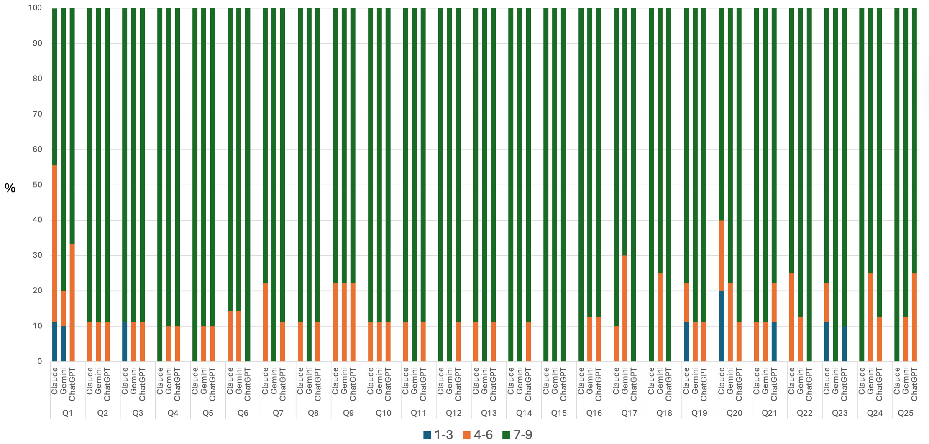
Figure S2. Proportion of panelists scoring in each category (1–3 = disagreement, 4–6 = no consensus, 7–9 = agreement) per response and large language model in muscle-invasive bladder cancer after both Delphi rounds.

Table S5. Delphi consensus on responses generated by three large language models to upper tract urothelial carcinoma management questions.
Guideline-based questions | Delphi results by LLM^{1,2} |  |  | Summary of main panelists’ comments
Guideline-based questions | Claude | Gemini | ChatGPT | Summary of main panelists’ comments
- Which patients are not suitable candidates for platinum-based therapy? | 1st round (100%) | 1st round (83.3%) | 1st round (83.3%) | Claude: Clear description but incorrect alternatives. Most comprehensive response among models.
- What is the current recommendation regarding intravesical chemotherapy instillation after radical nephroureterectomy (RNU) to reduce the risk of bladder recurrence in patients with upper urinary tract urothelial carcinoma (UTUC)? | No consensus (33.3%) | 1st round (100%) | 1st round (100%) | Claude: The response is inaccurate and not strongly supported by evidence.
- What regulatory approval has adjuvant nivolumab received for muscle-invasive urothelial carcinoma, and what have been the clinical outcomes in patients with upper urinary tract urothelial carcinoma (UTUC)? | 2nd round (100%) | 1st round (100%) | 1st round (100%) | Claude: Data presentation lacks clarity.
- Is endoscopic conservative management feasible for a 1 cm ureteral tumor causing urinary tract obstruction and secondary hydronephrosis? | 1st round (83.3%) | 1st round (100%) | 1st round (100%)
- Is a single dose of intravesical chemotherapy necessary following diagnostic ureterorenoscopy performed without biopsy? | No consensus (66.6%) | 1st round (100%) | 2nd round (83.3%) | Claude: The response presents some inaccuracies.
- Is tumor multifocality an independent prognostic factor for categorizing a tumor as high-risk? | 1st round (100%) | 1st round (83.3%) | 1st round (100%) | Claude: Best clarity among responses
- Case scenario:  A 64-year-old male, active smoker (20 cigarettes/day), with hypertension and chronic renal insufficiency secondary to nephroangiosclerosis (serum creatinine: 1.7 mg/dL; glomerular filtration rate: 55 mL/min), and a family history of colorectal and endometrial cancer. Following an episode of hematuria, the following diagnostic tests were performed:  - Negative voided urinary cytology.  - CT urography: 3.2 cm filling defect in the distal left ureter; mild to moderate ureterohydronephrosis. Three calyceal filling defects in the right kidney, the largest measuring 7 mm, with no hydronephrosis.  - Bilateral ureteroscopy: selective cytology and biopsies from all right renal lesions and the left ureteral lesion.  - Pathology report: a) Right kidney: all lesions consistent with low-grade urothelial carcinoma; wall infiltration cannot be specified (local stage Tx). b) Left ureter: high-grade urothelial carcinoma; wall infiltration cannot be specified (local stage Tx).  - Right selective cytology: negative.  - Left selective cytology: urothelial carcinoma.  What would be the optimal therapeutic option for this patient? | No consensus (42.9%) | 1st round (100%) | 1st round (100%) | Claude: Response incomplete.  Gemini: Better explained and detailed, but some issues not addressed.  ChatGPT: Schematic yet valid.
- Case scenario:  A 63-year-old man with a history of radical nephroureterectomy for upper tract urothelial carcinoma (pT3 G1 N0 M0). During follow-up, he developed multiple visceral metastases that, upon biopsy, were confirmed as low-grade urothelial carcinoma.  Should treatment with enfortumab vedotin be initiated, or would erdafitinib be a better option? | No consensus (60.0%) | 1st round (100%) | 1st round (80.0%) | Claude: The response presents some inaccuracies.
- What are the anatomic limits of lymphadenectomy in a male with UTUC localized to the left mid-ureter? | No consensus (60.0%) | 1st round (80.0%) | No consensus (60.0%)
- Among imaging modalities (CT, MRI, ultrasound, pyelography, etc.), which offers the best diagnostic performance for detection and recurrence of upper tract urothelial tumors? | 1st round (100%) | 1st round (85.7%) | 1st round (85.7%) | Claude: Response clear and concise.
- In patients with renal insufficiency, what is the most appropriate imaging algorithm for detecting upper tract tumors? | 1st round (100%) | 1st round (100%) | 1st round (100%)
- What is the recommended CT protocol and which phases after intravenous iodinated contrast should be used for UTUC diagnosis and follow-up? | 1st round (100%) | 1st round (85.7%) | 1st round (85.7%) | Gemini and ChatGPT: Responses not concise; contain unrelated details.
- In the context of Lynch syndrome, how and how often should the upper urinary tract be screened? | No consensus (66.6%) | 1st round (100%) | 1st round (100%) | Claude: consistently provides more schematic responses.
- As a prognostic factor, how should multifocality in UTUC be defined: by location, by number, or both? | 1st round (100%) | 1st round (100%) | 1st round (100%) | Claude: Clear
- For low-grade distal ureteral tumors, which approach yields better oncologic outcomes: endoscopic resection or partial ureterectomy with reimplantation? | 1st round (100%) | 1st round (100%) | 1st round (100%)
- Is biopsy indispensable for the diagnosis of upper tract tumors? | 1st round (100%) | 1st round (100%) | 1st round (85.7%) | Claude: Clear and concise
- Should we always wait for a definitive result from selective ureteral cytology in cases suspicious for upper tract tumors? | 1st round (100%) | 1st round (100%) | 1st round (100%) | Claude: Clear and concise response, as almost always.  Gemini: Responds but with too much detail; rarely concise.  ChatGPT: Response correct but too brief.
- What is the best alternative for treating a patient with bilateral diffuse CIS in both collecting systems? | No consensus (33.3%) | 1st round (100%) | 1st round (100%) | Claude: Response incomplete.  Gemini: In this case, it is the clearest and most detailed.
- Is it necessary to perform retroperitoneal lymphadenectomy up to the renal hilum in a patient with a high-grade distal ureteral urothelial carcinoma staged cT3? | No consensus (50.0%) | 1st round (100%) | 1st round (100%) | Claude: The response presents some inaccuracies.
- Case scenario:  A 58-year-old man with Lynch syndrome and a 1 cm low-grade urothelial carcinoma in the right renal pelvis and multiple hilar lymphadenopathies up to 2.5 cm in diameter, consistent with low-grade urothelial carcinoma metastases.  What would be the best treatment option in this setting? | No consensus (60.0%) | 1st round (100%) | 1st round (80%) | Claude: The response presents some inaccuracies.
- Is local adjuvant therapy with MMC or BCG necessary after conservative management of upper tract transitional cell carcinoma? | 1st round (83.3%) | 1st round (100%) | 1st round (100%) | Gemini: Overly wordy
- What is the role of upper tract chemotherapy instillation in the ablative treatment of transitional cell tumors? | No consensus (50.0%) | 1st round (100%) | 1st round (100%) | Claude: The response presents some inaccuracies.
- What deleterious effect does mitomycin C instillation for treatment of upper tract urothelial carcinoma have on the renal parenchyma? | 2nd round (83.3%) | 1st round (100%) | 1st round (100%)
- What is the risk of tumor seeding along the tract following percutaneous surgery for conservative treatment of a low-grade renal pelvic urothelial tumor? | 1st round (100%) | 1st round (100%) | 1st round (100%)
- In the case of diffuse carcinoma in situ of the upper urinary tract, what is the treatment of choice? What is the efficacy of BCG instillation in the upper tract and what is the optimal treatment regimen? | No consensus (50.0%) | 1st round (100%) | 1st round (83.3%)
Abbreviations: BCG, Bacillus Calmette-Guérin; CIS, Carcinoma in situ; CT, Computed Tomography; MRI, Magnetic Resonance Imaging; RNU, Radical Nephroureterectomy; UTUC, upper tract urothelial carcinoma.

¹ ‘1st round’ or ‘2nd round’ indicates consensus was reached in the first or second Delphi round, respectively.
² The percentage in parentheses indicates the proportion of panelists whose scores fell within the same tercile as the median of responses (1–3 = disagreement, 4–6 = no consensus, 7–9 = agreement).
³ Panelists (n) indicates the number of panelists who rated each response; abstentions were excluded from all calculations.

Color code for consensus levels:
- Dark green: Consensus in agreement reached in the first round.
- Light green: Consensus in agreement reached in the second round.
- Yellow: No consensus reached.

Table S6. Number of panelists, median score, and interquartile range for each question and large language model in upper tract urothelial carcinoma.
Question¹ | Claude |  | Gemini |  | ChatGPT
Question¹ | n | Median (IQR) | n | Median (IQR) | n | Median (IQR)
1 | 6 | 9 (1) | 6 | 7 (0) | 6 | 7 (0)
2 | 6 | 6 (6) | 6 | 8.5 (1) | 6 | 8.5 (1)
3 | 5 | 7 (2) | 6 | 9 (0) | 6 | 7.5 (1)
4 | 6 | 7.5 (1) | 6 | 8 (1) | 6 | 8 (1)
5 | 6 | 7 (2) | 6 | 8.5 (1) | 6 | 7.5 (1)
6 | 6 | 8.5 (1) | 6 | 7 (0) | 6 | 8 (1)
7 | 7 | 6 (5) | 6 | 8.5 (1) | 6 | 9 (1)
8 | 5 | 3 (5) | 5 | 9 (1) | 5 | 8 (2)
9 | 5 | 7 (2.5) | 5 | 9 (3) | 5 | 6 (1.5)
10 | 7 | 8 (1) | 7 | 9 (0) | 7 | 9 (1)
11 | 7 | 9 (1) | 7 | 8 (2) | 7 | 9 (1)
12 | 7 | 8 (0) | 7 | 8 (1) | 7 | 9 (2)
13 | 6 | 7 (5) | 6 | 9 (1) | 6 | 8 (1)
14 | 6 | 9 (1) | 6 | 8 (0) | 6 | 7.5 (1)
15 | 6 | 8.5 (1) | 6 | 9 (1) | 6 | 8.5 (1)
16 | 7 | 8 (1) | 7 | 8 (0) | 7 | 8 (2)
17 | 5 | 8 (1) | 5 | 8 (0.5) | 5 | 7 (2)
18 | 6 | 6 (4) | 6 | 7.5 (2) | 6 | 8.5 (1)
19 | 6 | 5.5 (4) | 6 | 8.5 (1) | 6 | 8.5 (2)
20 | 5 | 6 (3) | 5 | 9 (0.5) | 5 | 8 (2)
21 | 6 | 8.5 (2) | 6 | 8 (2) | 6 | 8 (2)
22 | 6 | 6 (1) | 6 | 8 (1) | 6 | 8 (0)
23 | 6 | 7.5 (2) | 6 | 8 (2) | 6 | 8 (2)
24 | 6 | 8.5 (2) | 6 | 7.5 (2) | 6 | 7.5 (2)
25 | 6 | 6 (2) | 6 | 8 (0) | 6 | 8 (0)
Abbreviations: IQR, interquartile range.
¹ Question numbers correspond to those reported in Table S5. For each model and question, n indicates the number of panelists who submitted a rating. Abstentions were excluded.

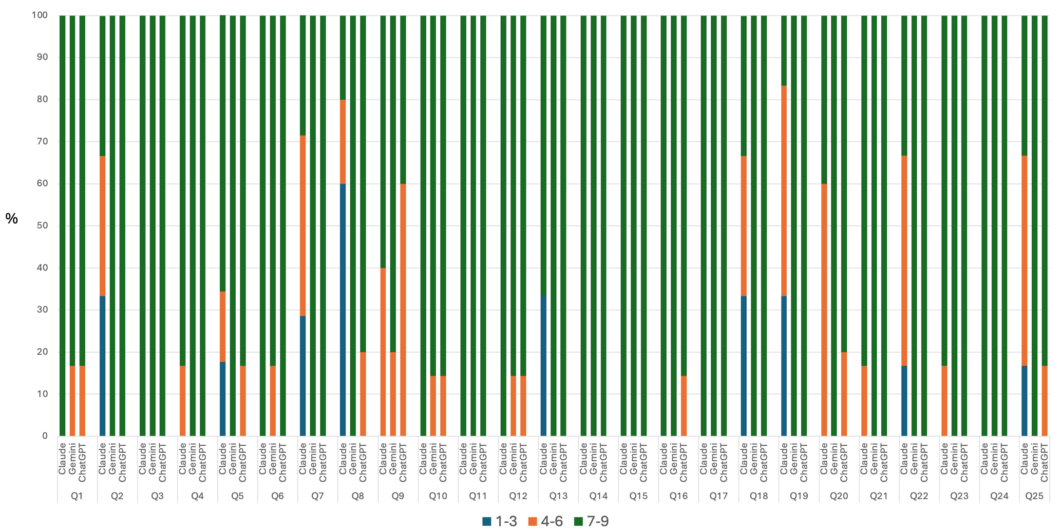
Figure S3. Proportion of panelists scoring in each category (1–3 = disagreement, 4–6 = no consensus, 7–9 = agreement) per response and large language model in upper tract urothelial carcinoma after both Delphi rounds.

